**DAILY ASSESSMENT FORMAT**

|  |  |  |  |
| --- | --- | --- | --- |
| **Date:** | **26/05/2020** | **Name:** | **K Gaurav Shet** |
| **Course:** | **Signals & Systems** | **USN:** | **4AL18EC023** |
| **Topic:** | 1. **Fourier Transform** 2. **Laplace Transform** 3. **Applications of Z-Transform** | **Semester & Section:** | **4th sem**  **‘A’ Section** |
| **Github Repository:** | **Gaurav-shet** |  |  |

**FORENOON SESSION**

**Image of session**

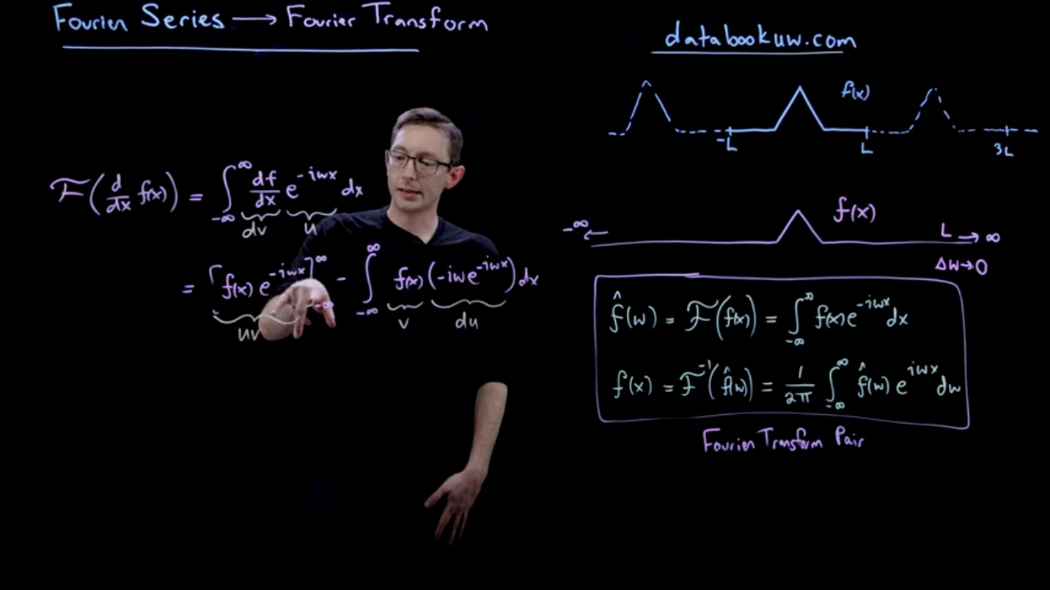

**Report**

**Fourier series and Gibbs Phenomena using Python**

**● What can go wrong**

**★ Discontinuous - real problem for the Fourier serie**

**➢ Fourier Transform**

**● How we generalise from periodic functions to the fourier transform which is**

**defined on an infinite domain**

**➢ The Fourier Transform and derivatives**

**● Method of approximating a continuous function f(x)**

**● Can use that either to approximate derivatives numerically very accurately or can**

**also use to transform from Partial Differential Equation into Ordinary Differential**

**Equation**

**➢ Fourier Transform and Convolution integrals**

**● If we have two functions f and g then if we Fourier transform the convolution it just**

**becomes the product in the Fourier transform domain**

**● Convolution becomes the product in the Fourier transform that is very useful**

**➢ Institute of Fourier transform and Laplace transform**

**➢ Laplce transform of First Order**

**● f(t) --- F(S)**

**● y(t) -- Y(S)**

**● When we take the derivative of a function we multiply its Laplace transform by s**

**that's the rule**

**● If we have two derivatives we multiply it by square of s**

**● Changed from t time in Differential Equation to s in the Laplace transform**